Final Report Submitted

*by* Ayush vij

**Submission date:** 08-Jan-2023 06:38PM (UTC+0530)

**Submission ID:** 1987641515

**File name:** Final_Project_Report.docx (1.22M)

**Word count:** 7255

**Character count:** 35653

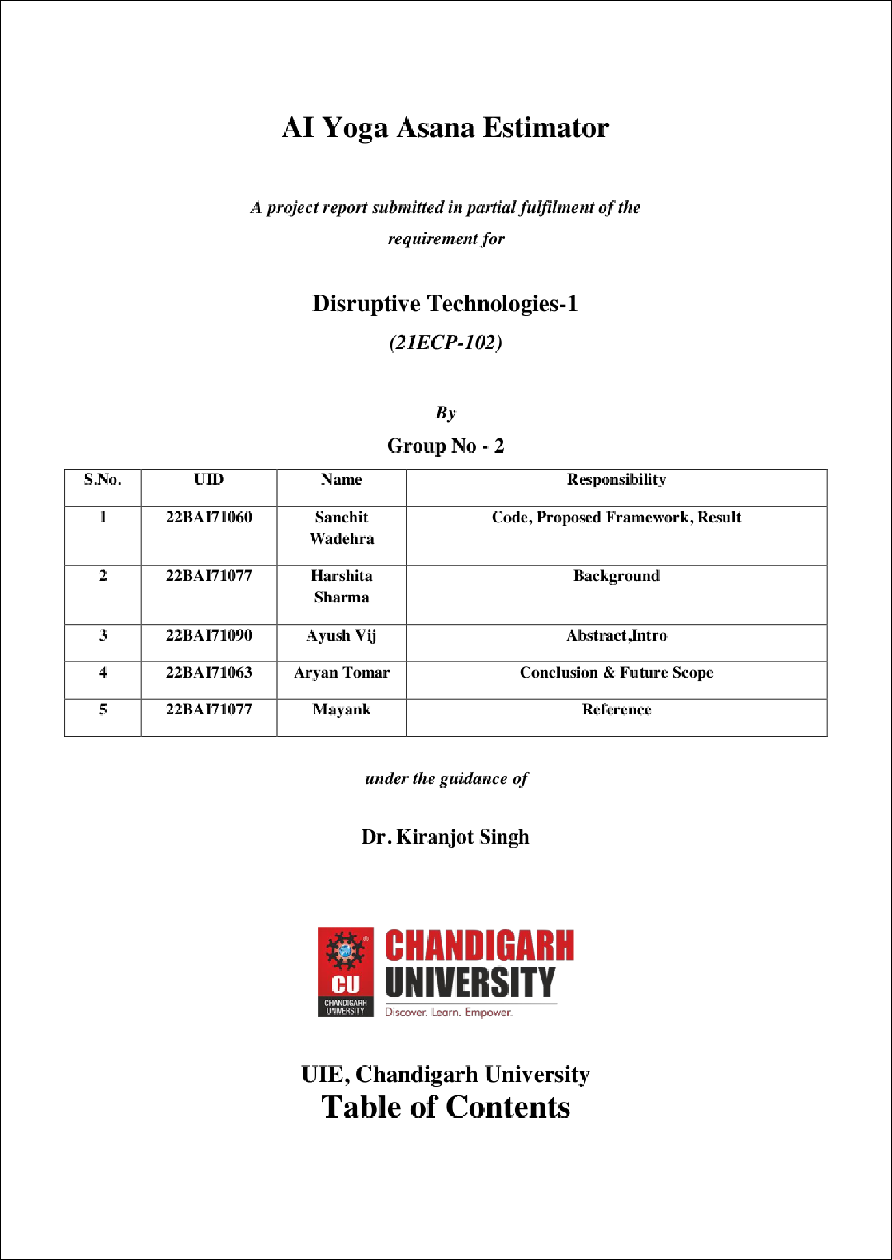

2

2

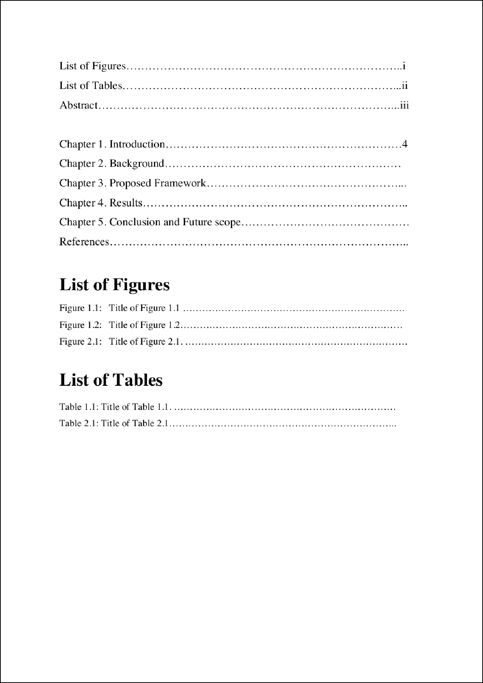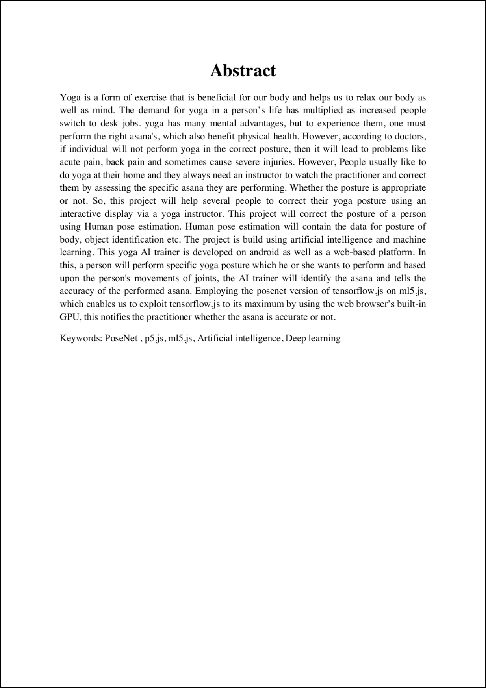

1

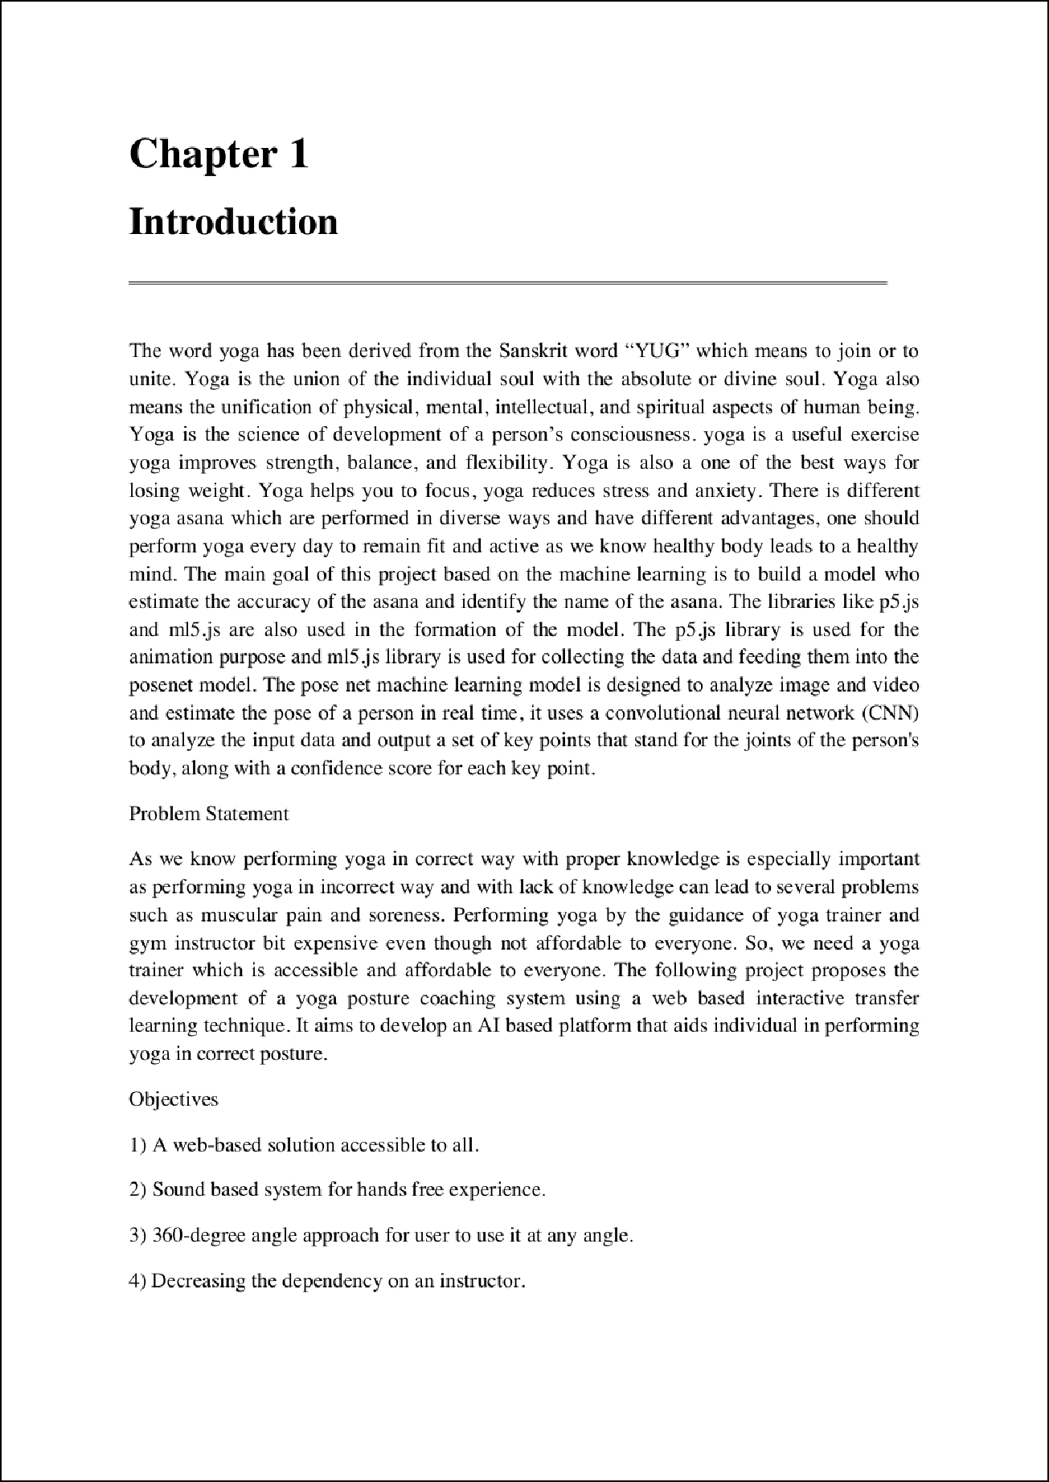

3

8

1

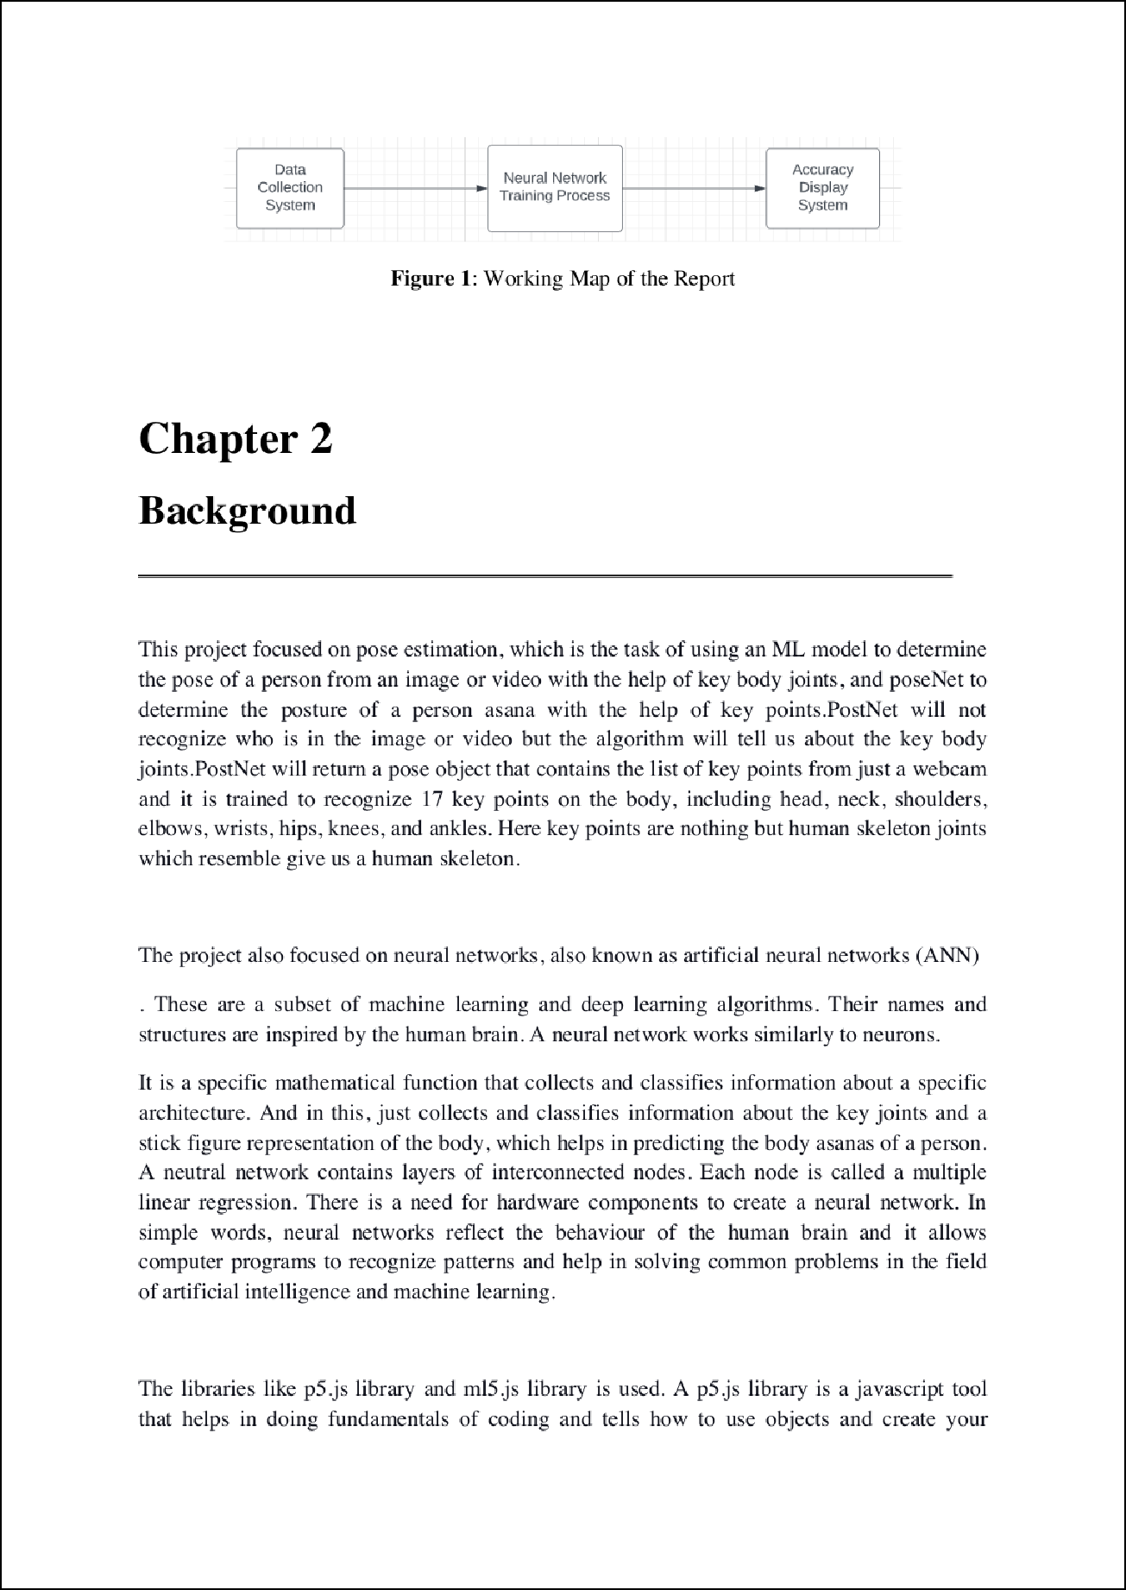

4

4

8

6

17

13

7

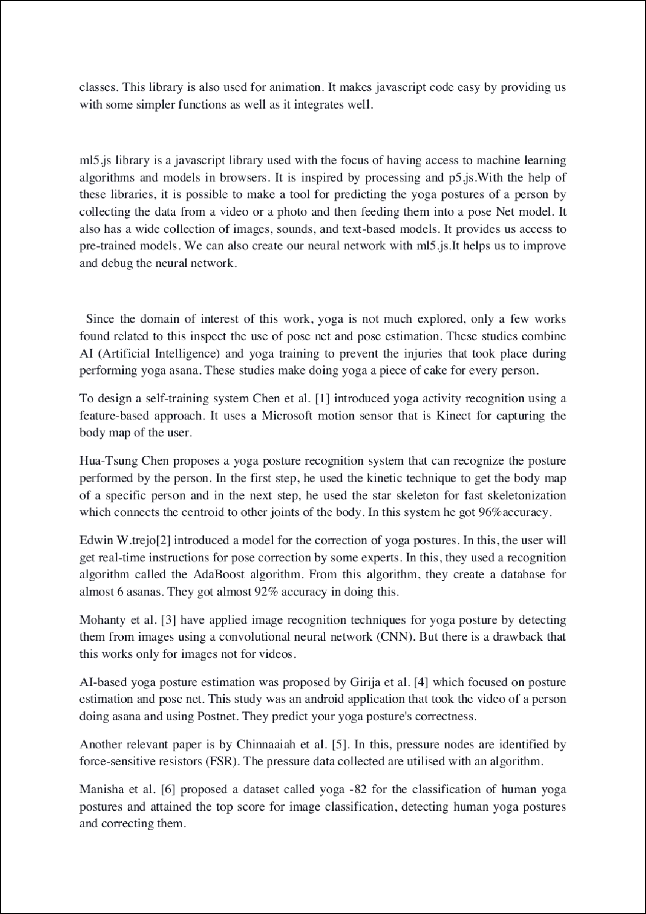

23 1

16

1

9

1

1

1

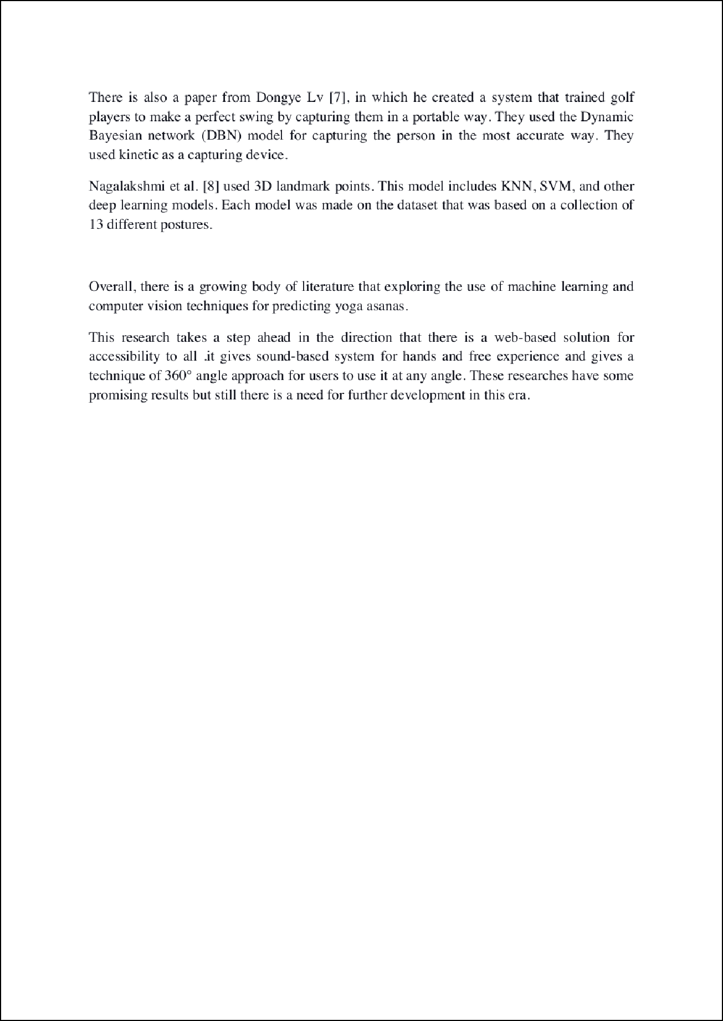

21

1

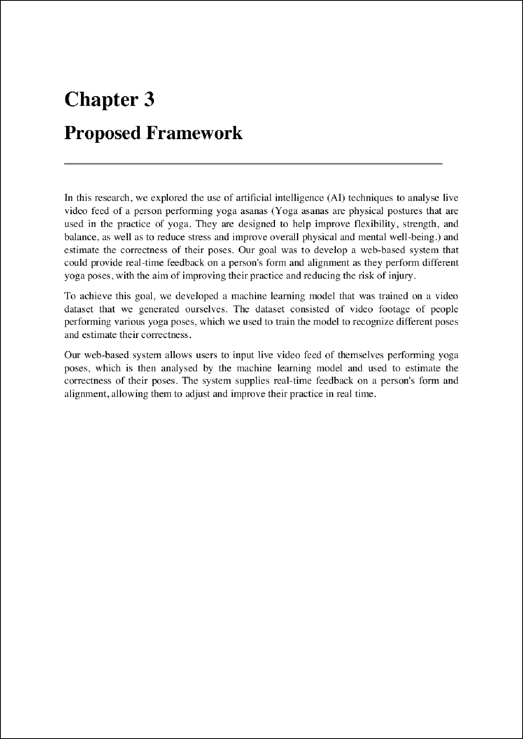

15

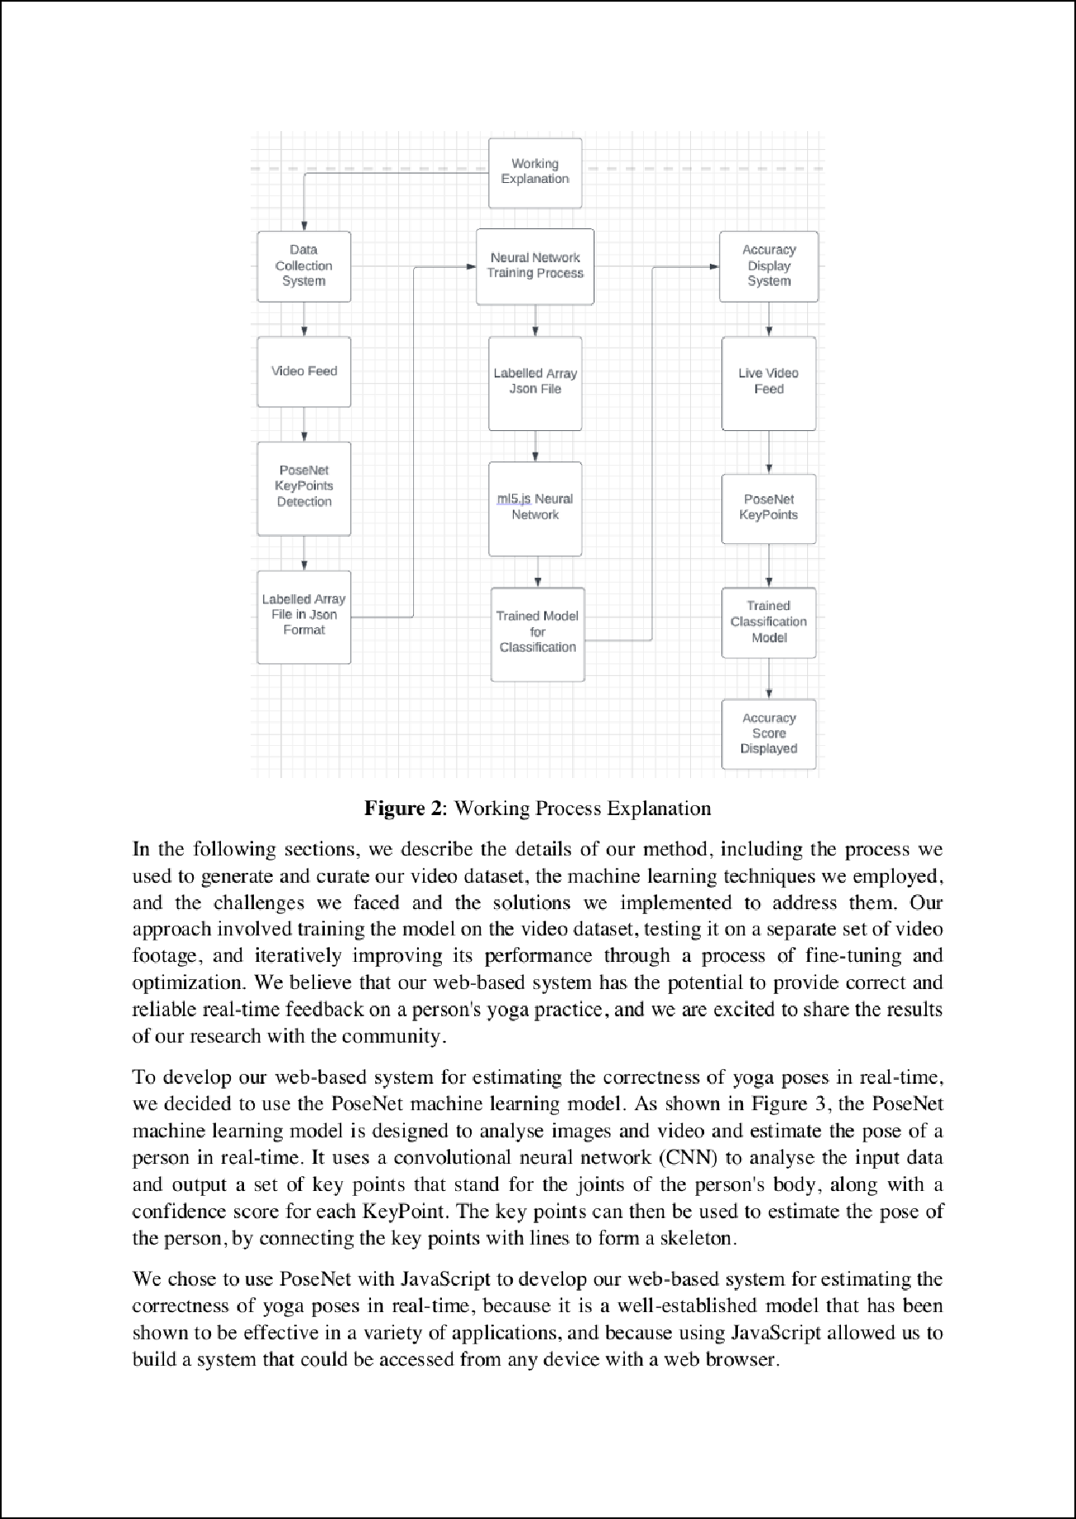

20

1

8

1

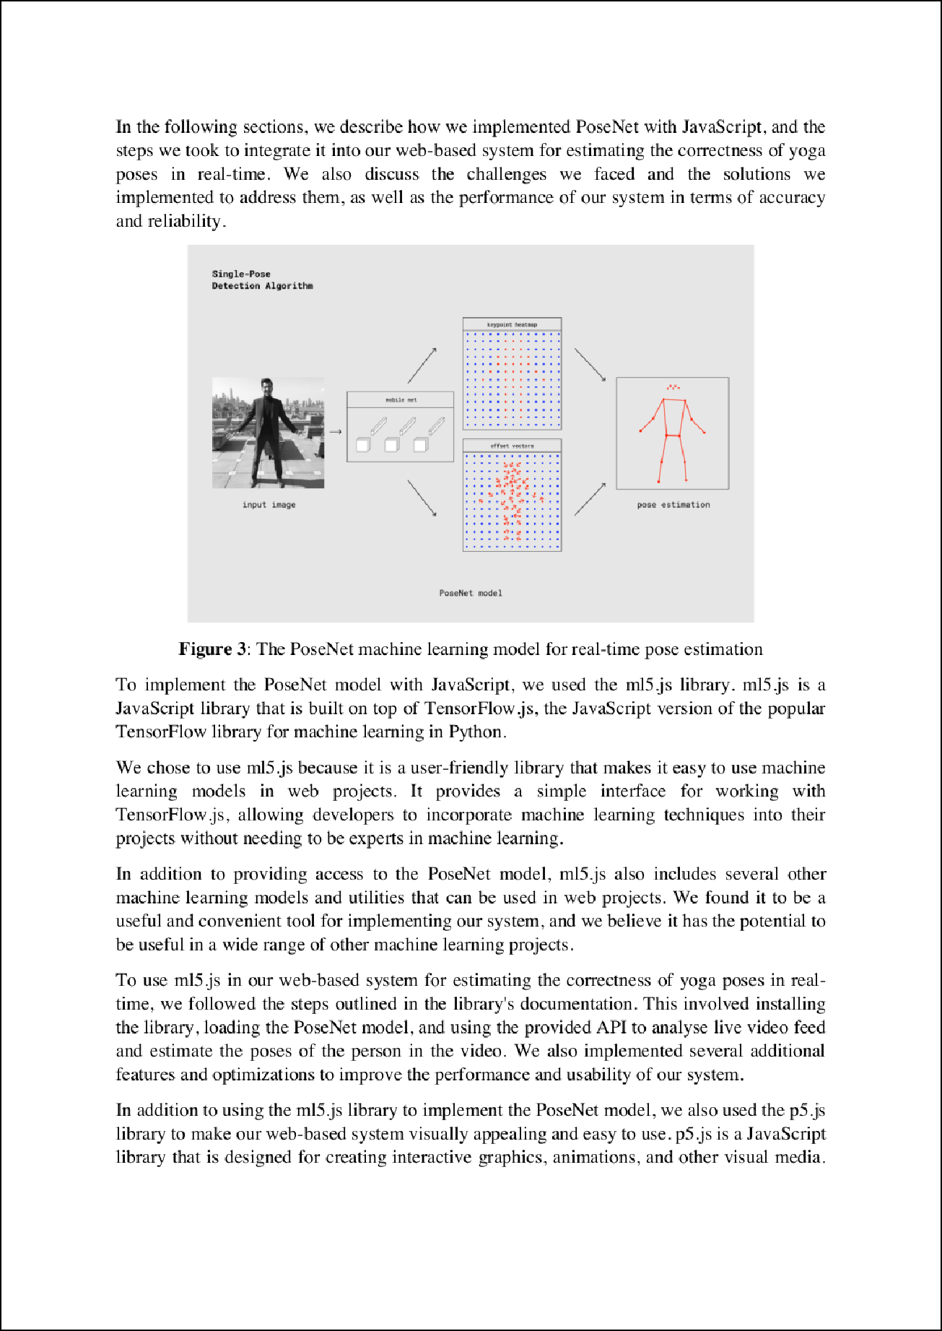

1

1

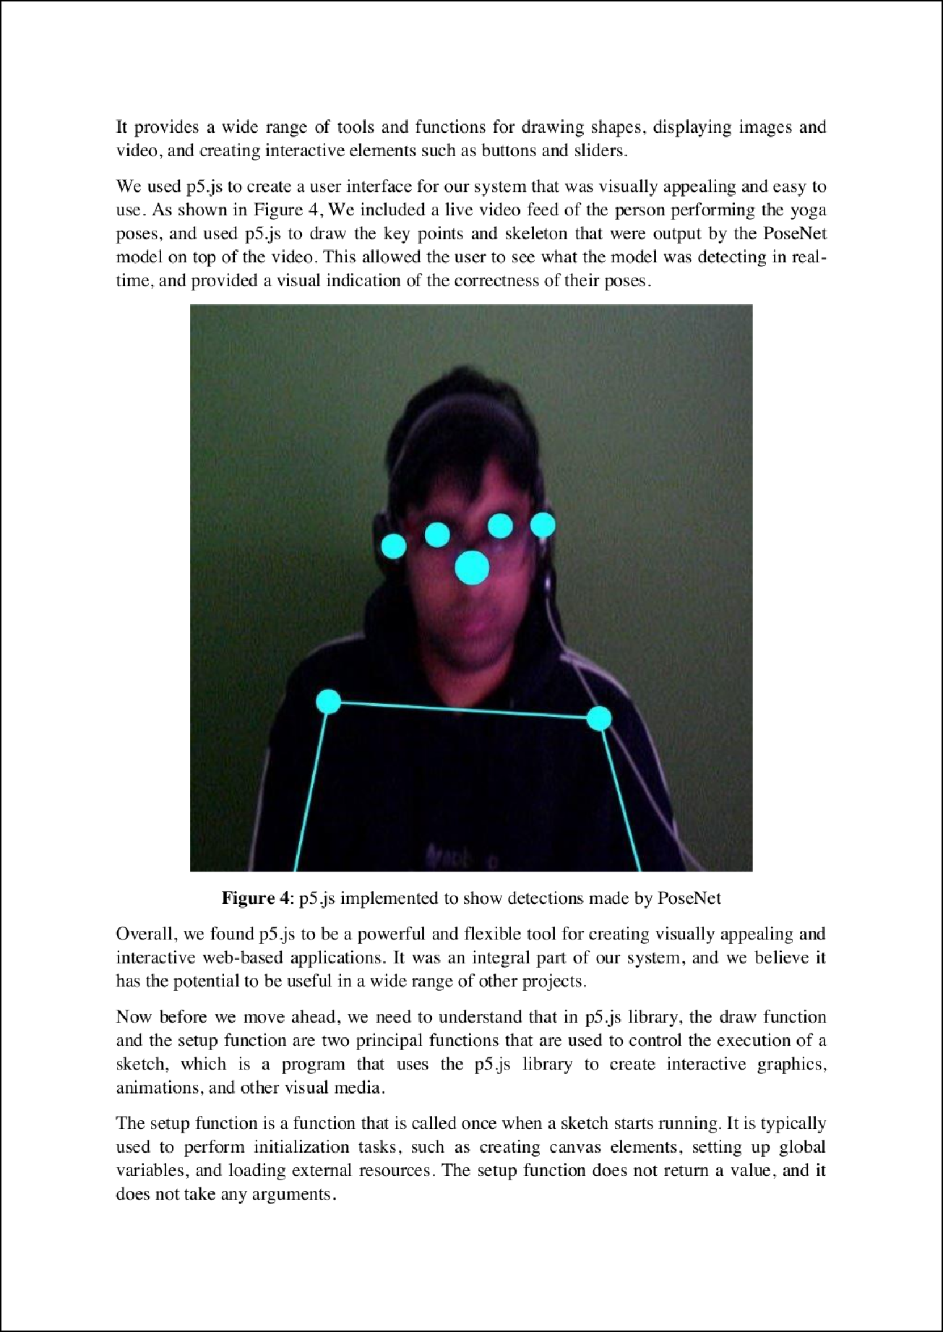

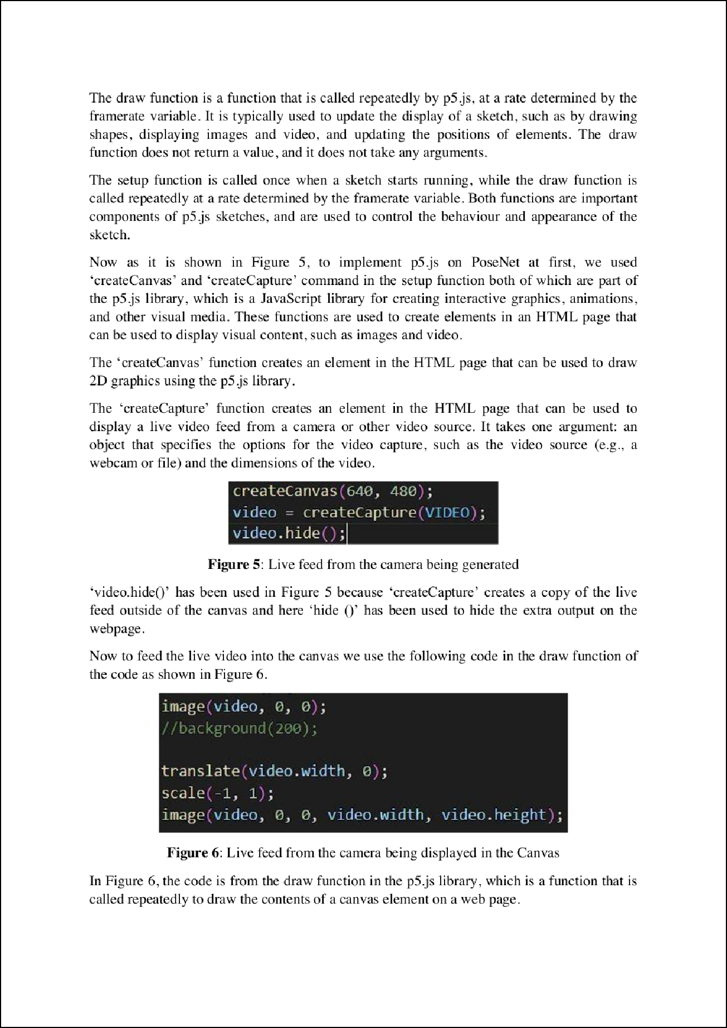

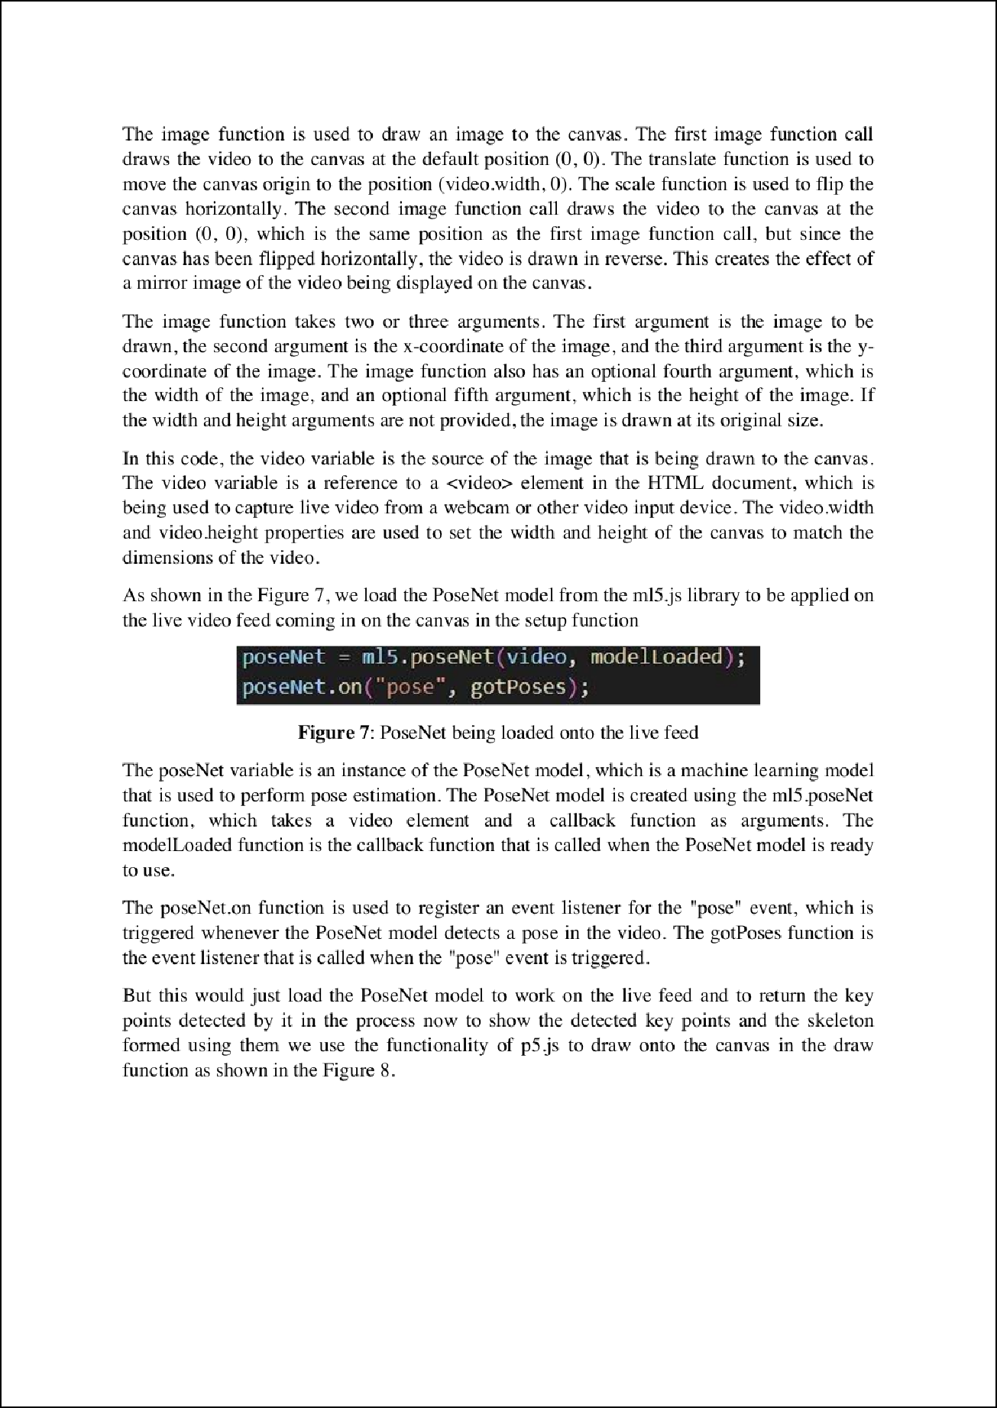

10

19

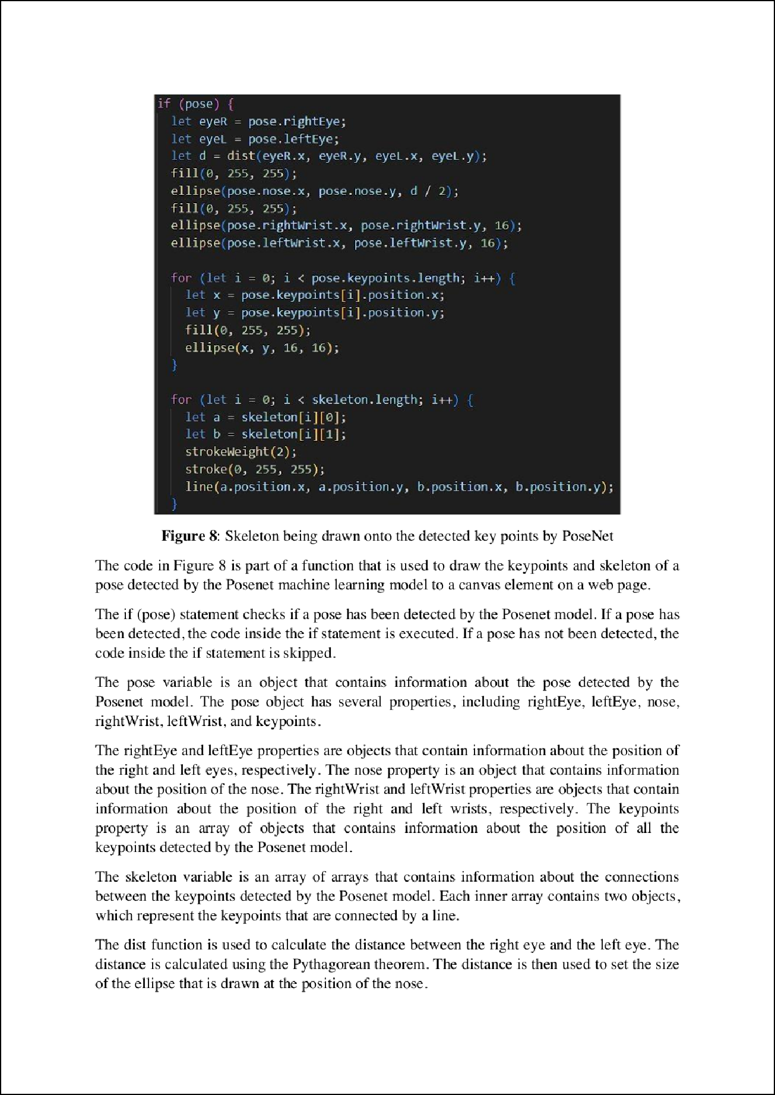

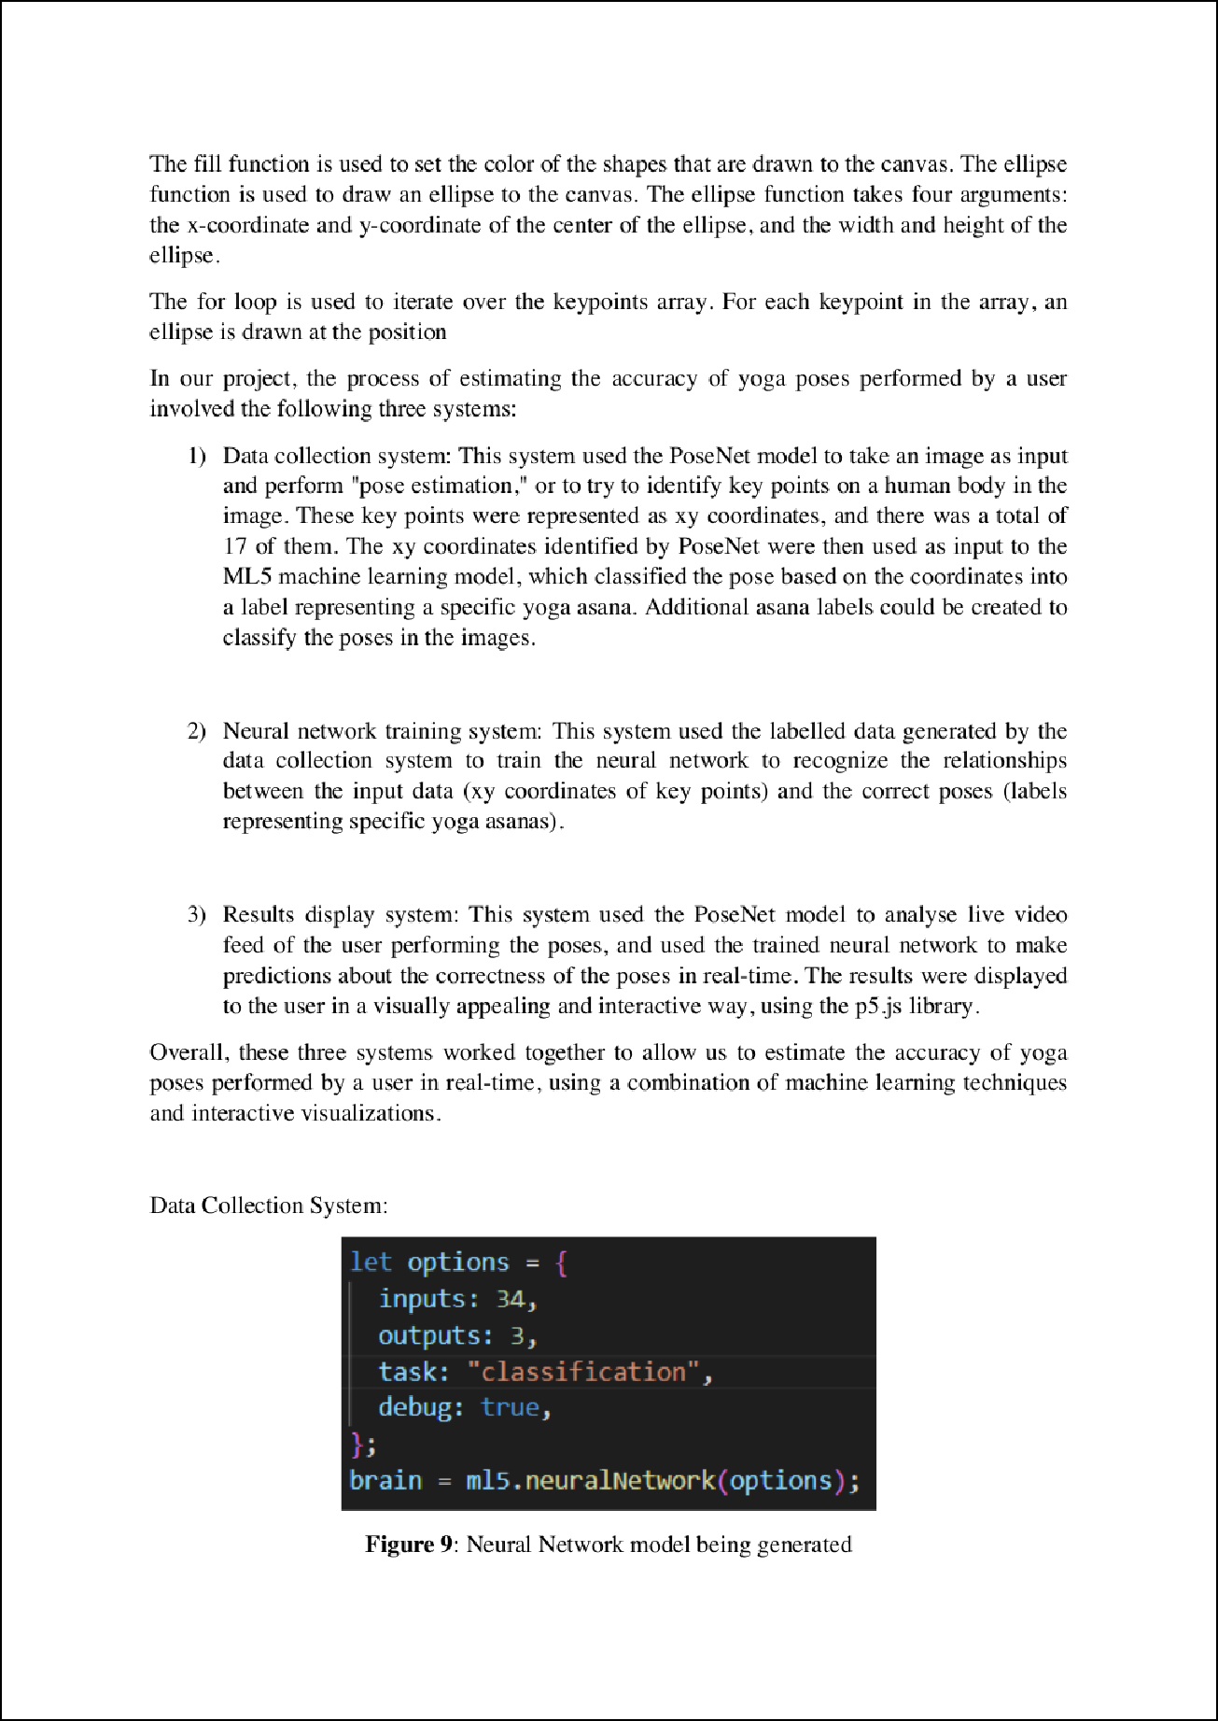

6

11

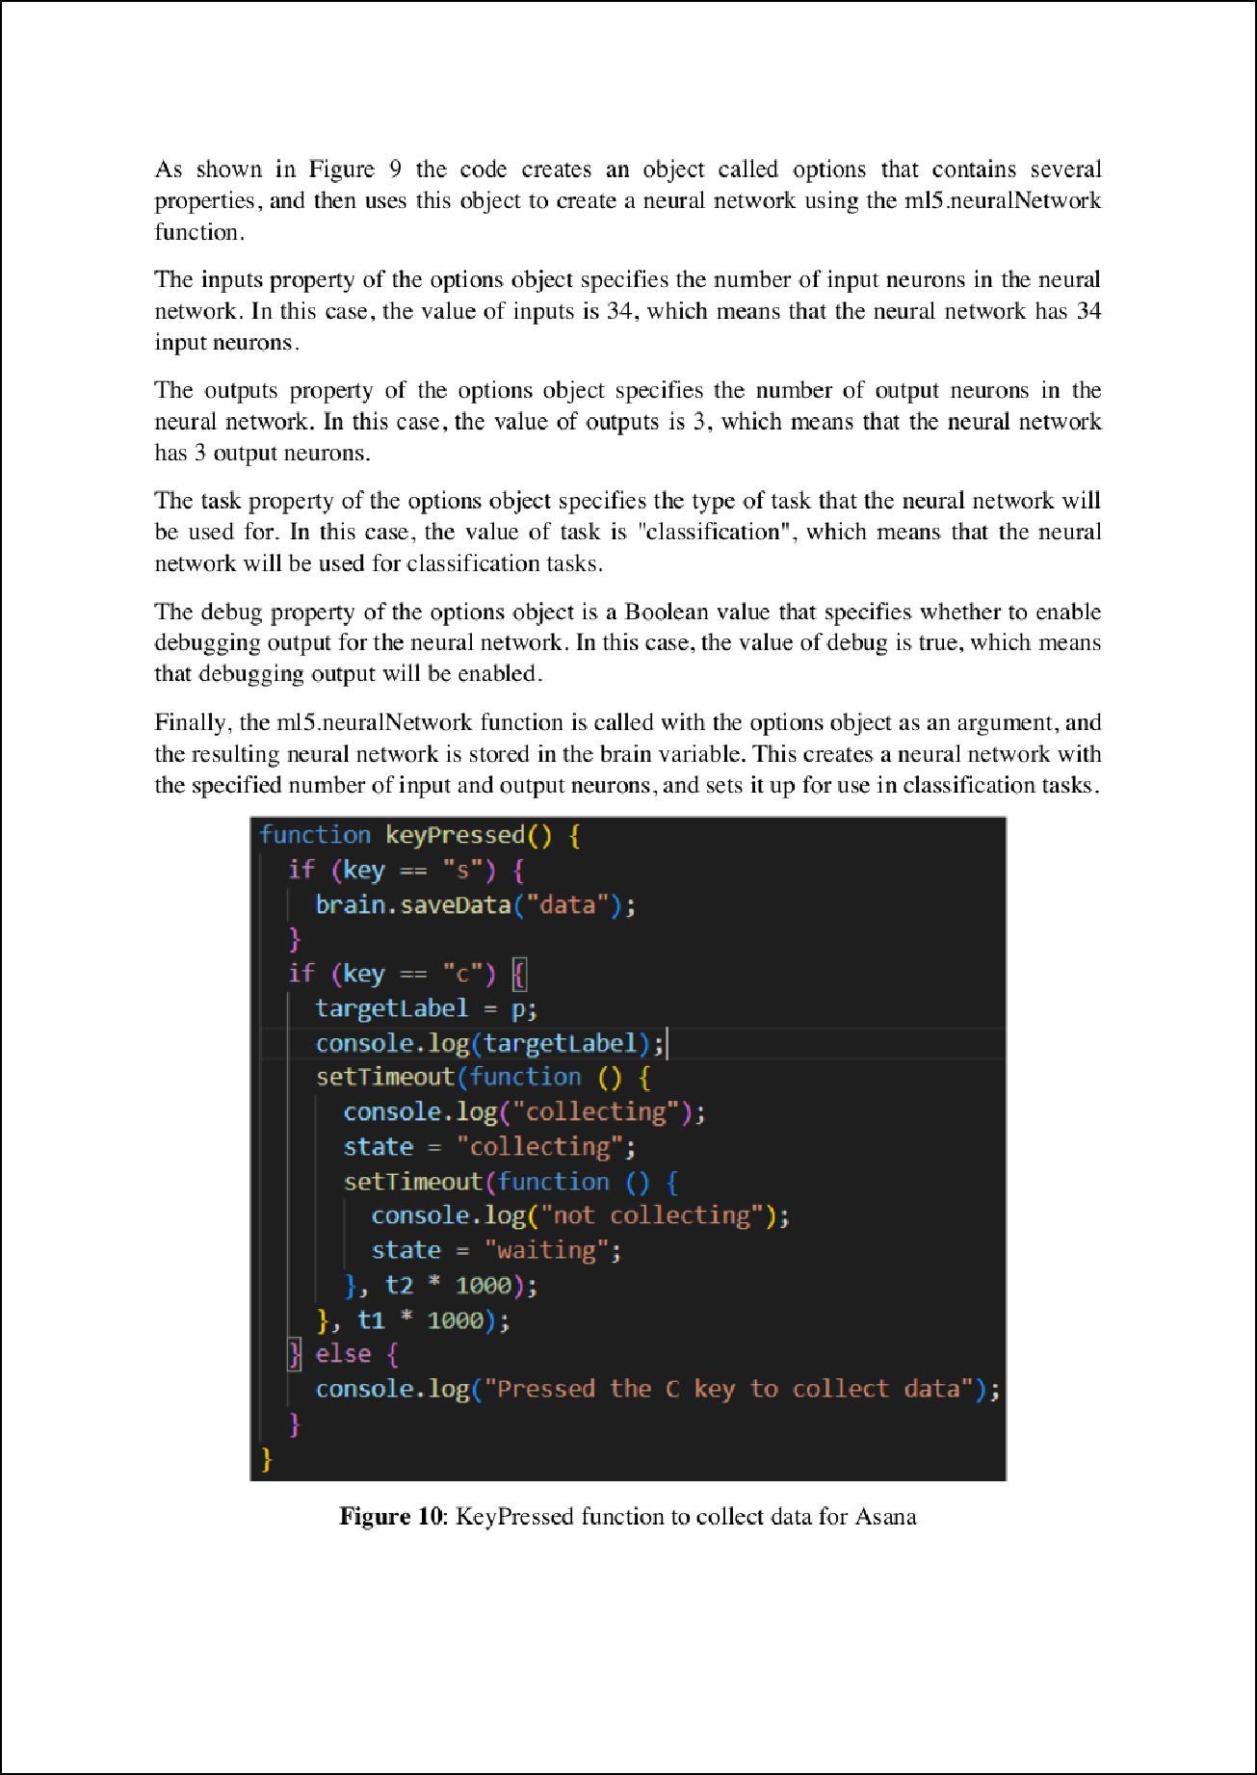

9

9

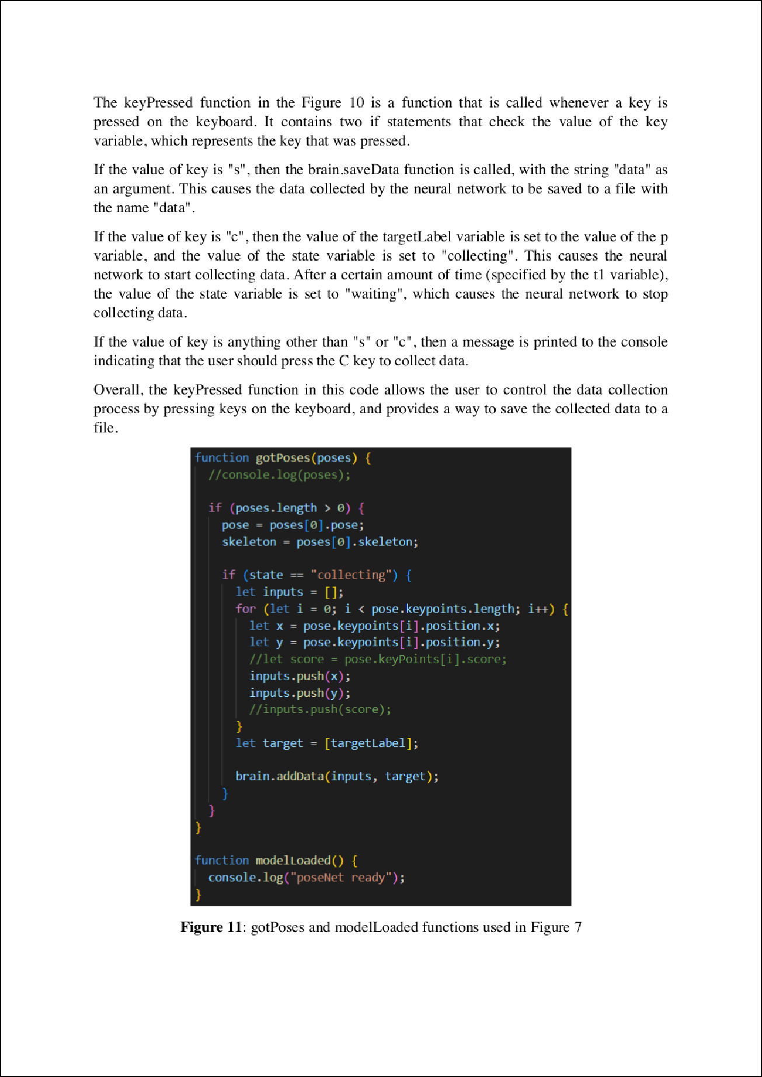

14

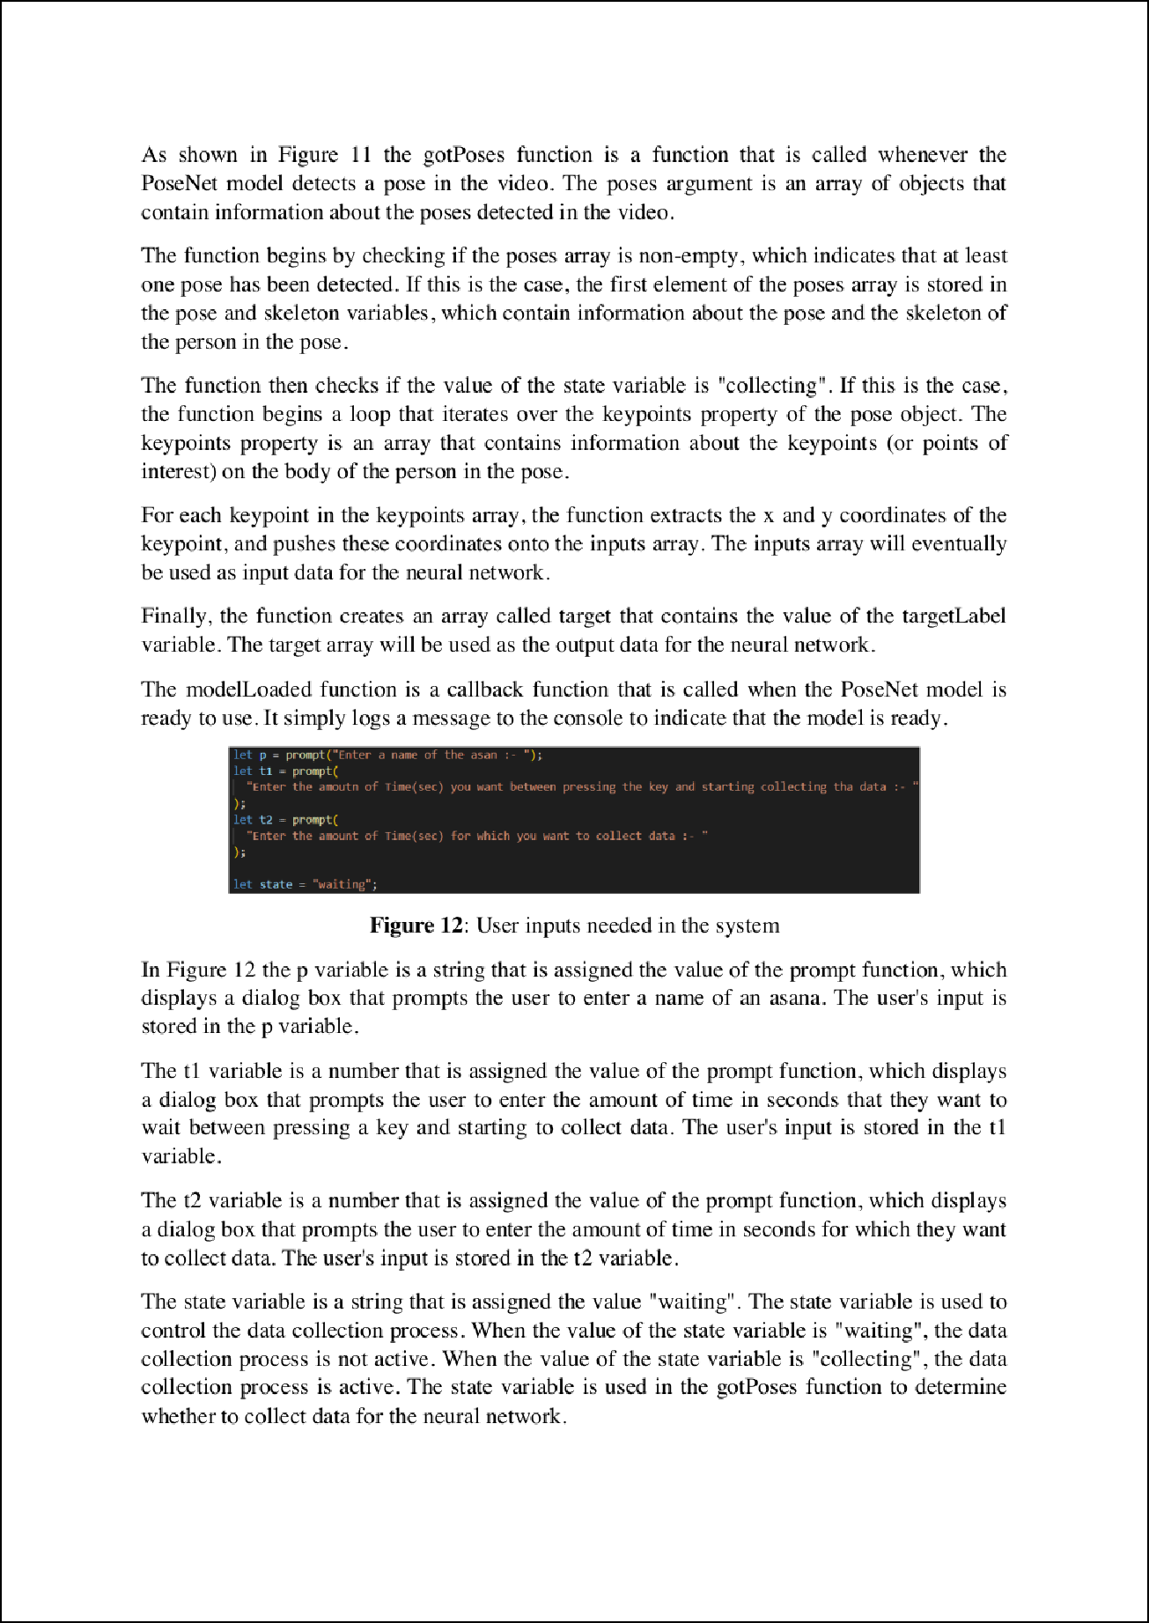

11

22

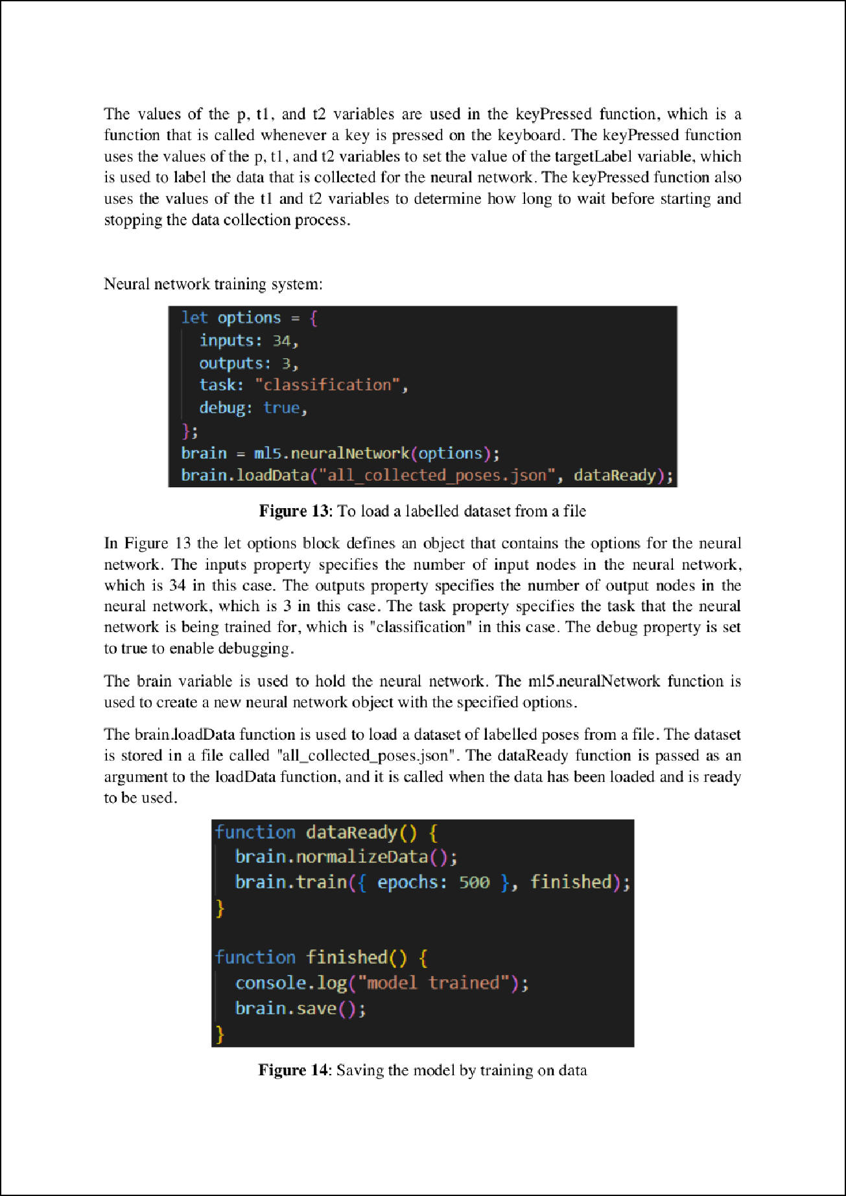

5

5

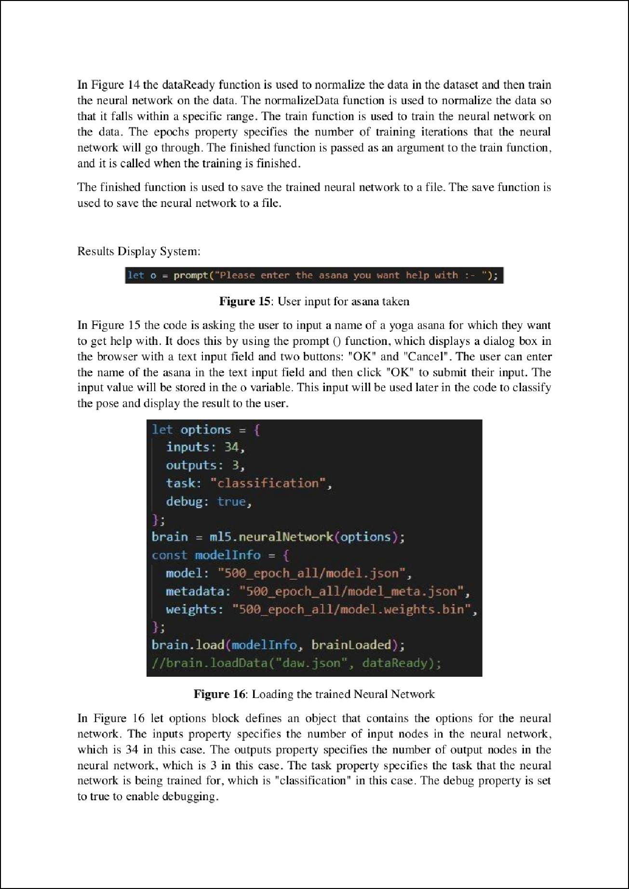

12

12

5

5

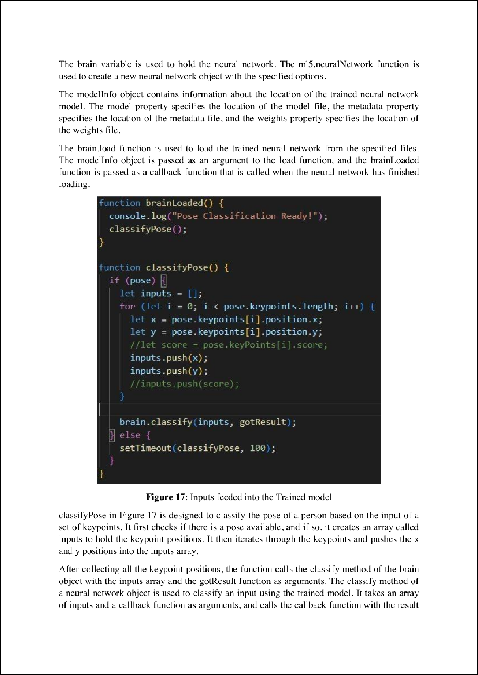

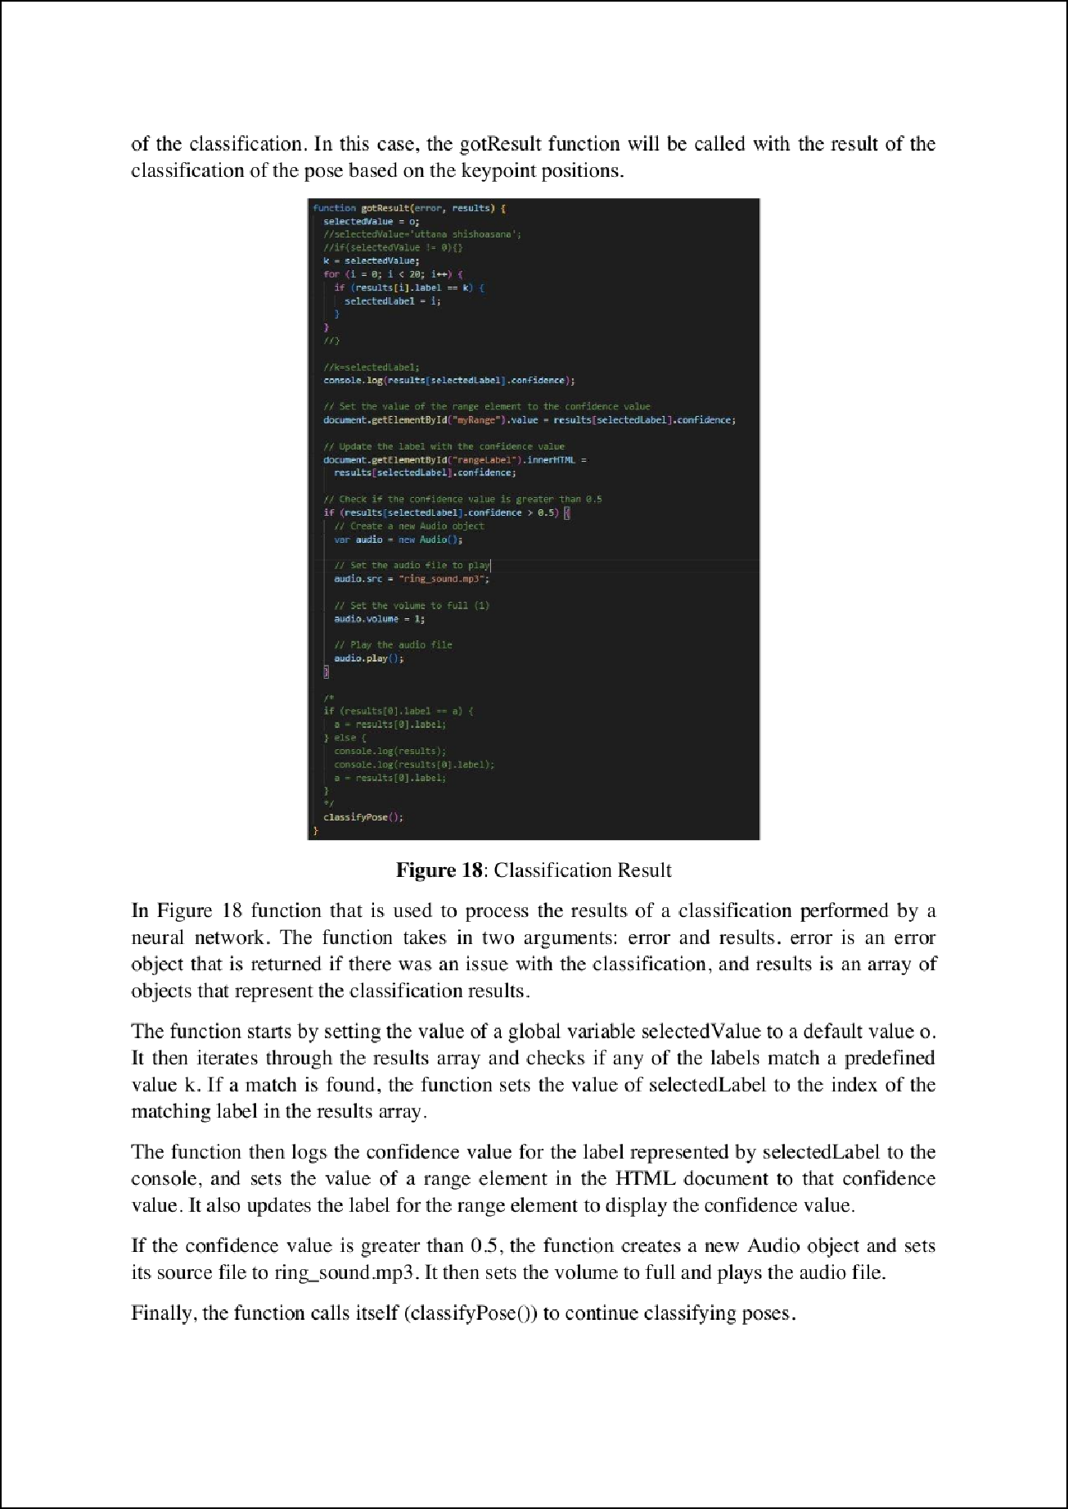



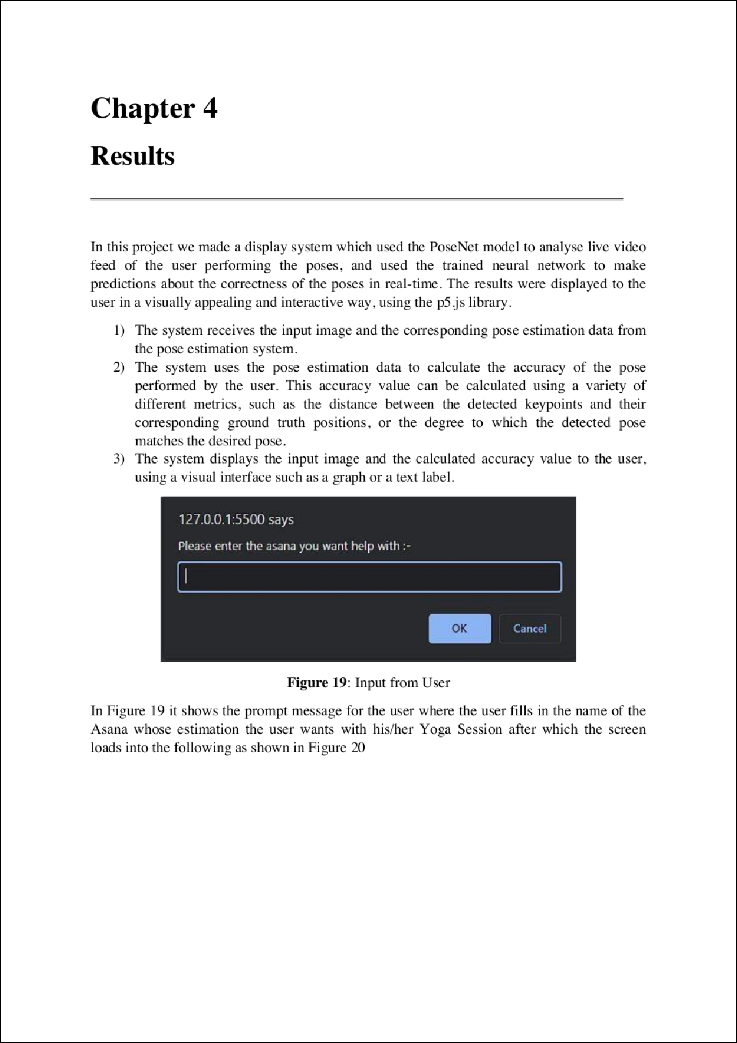

18

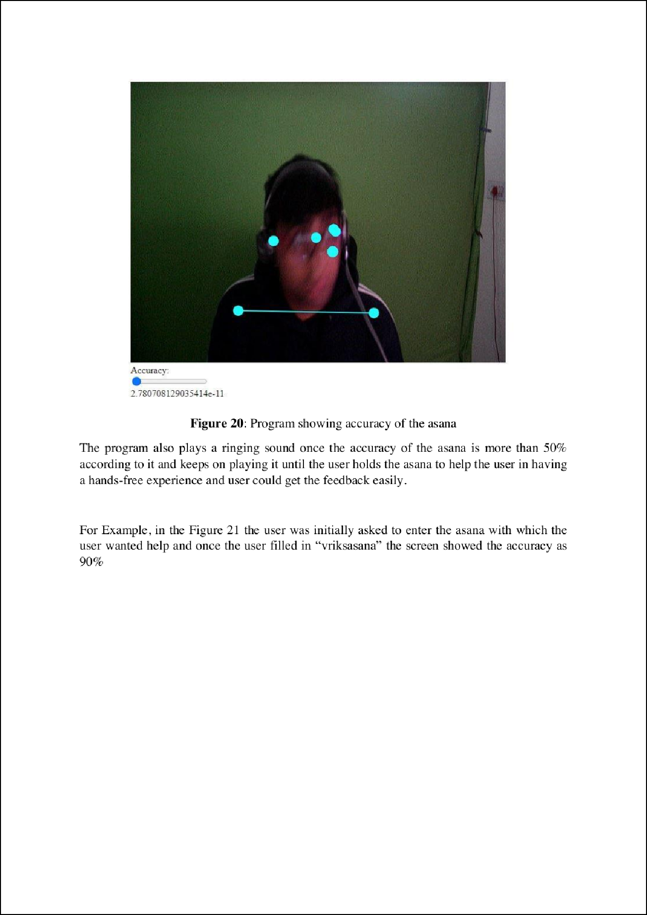

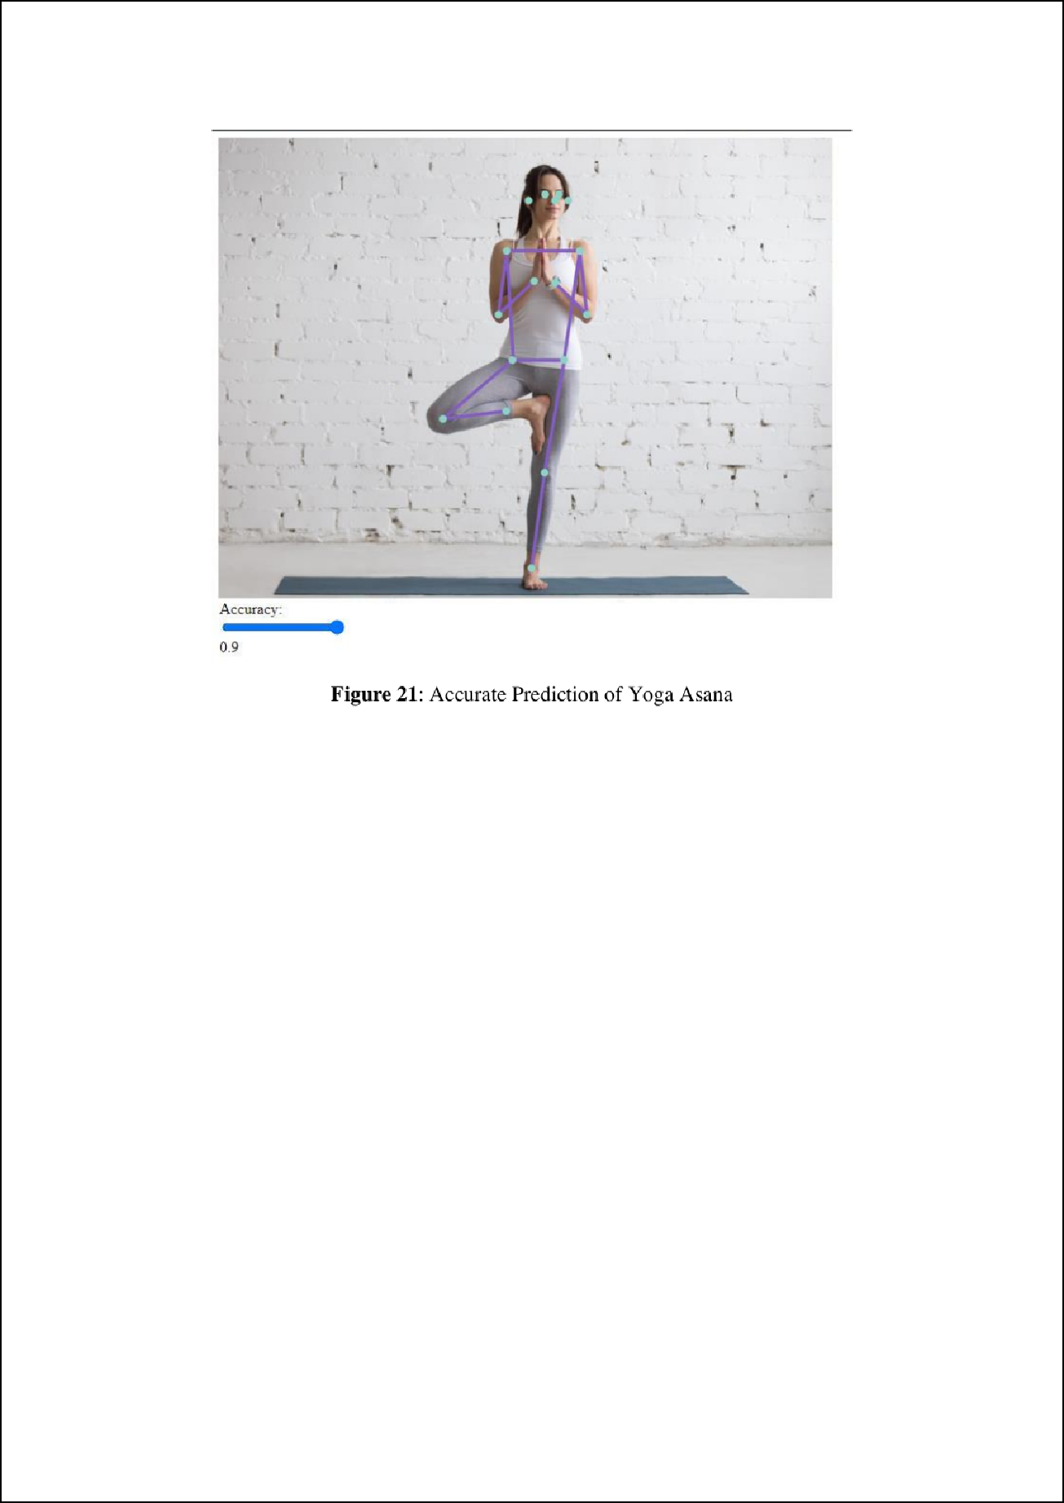

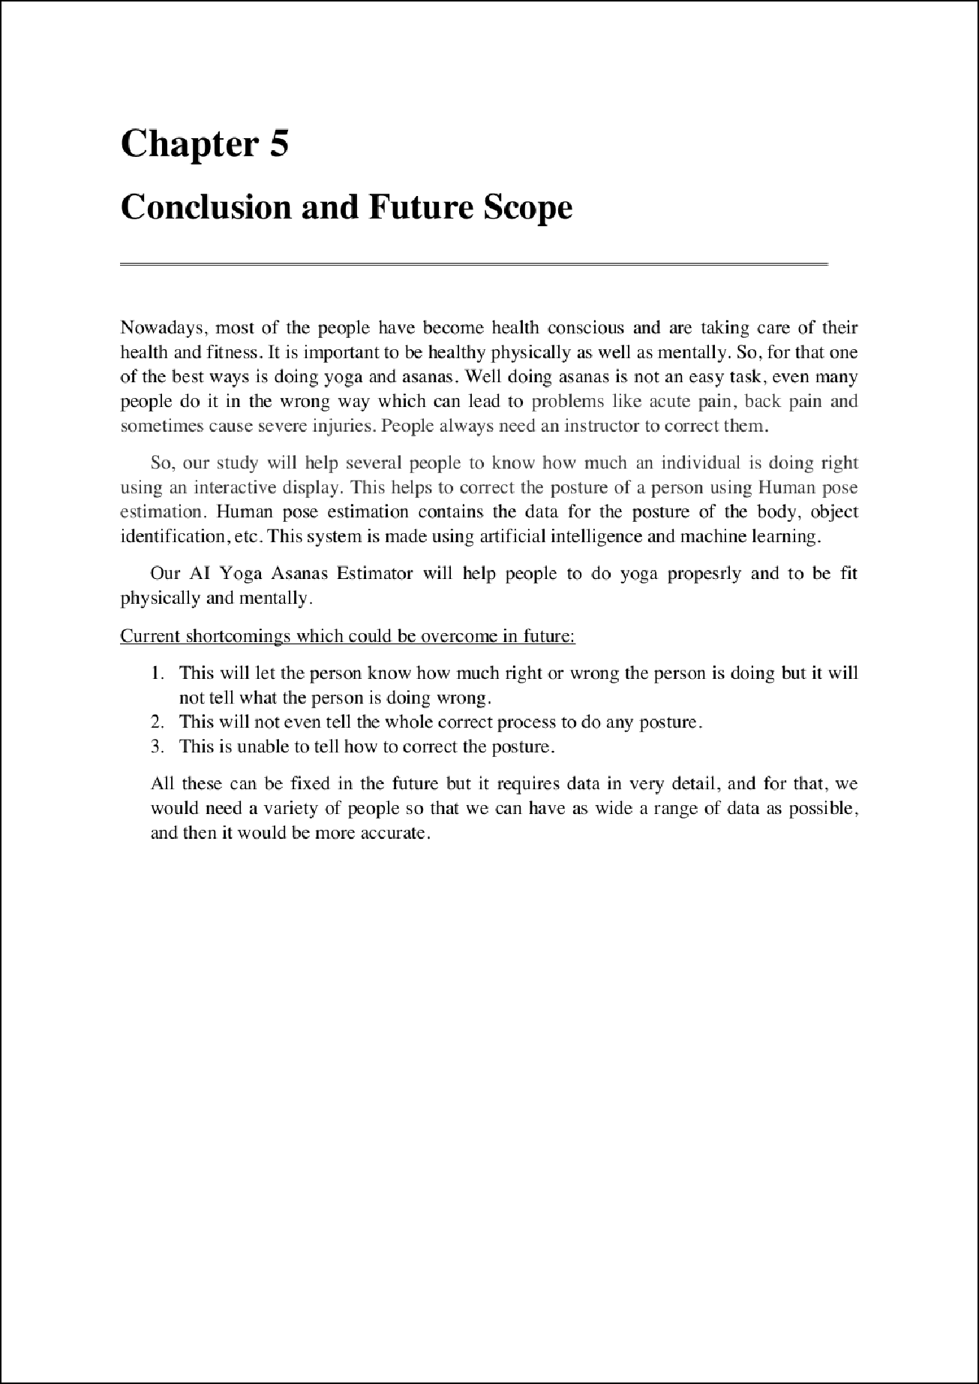

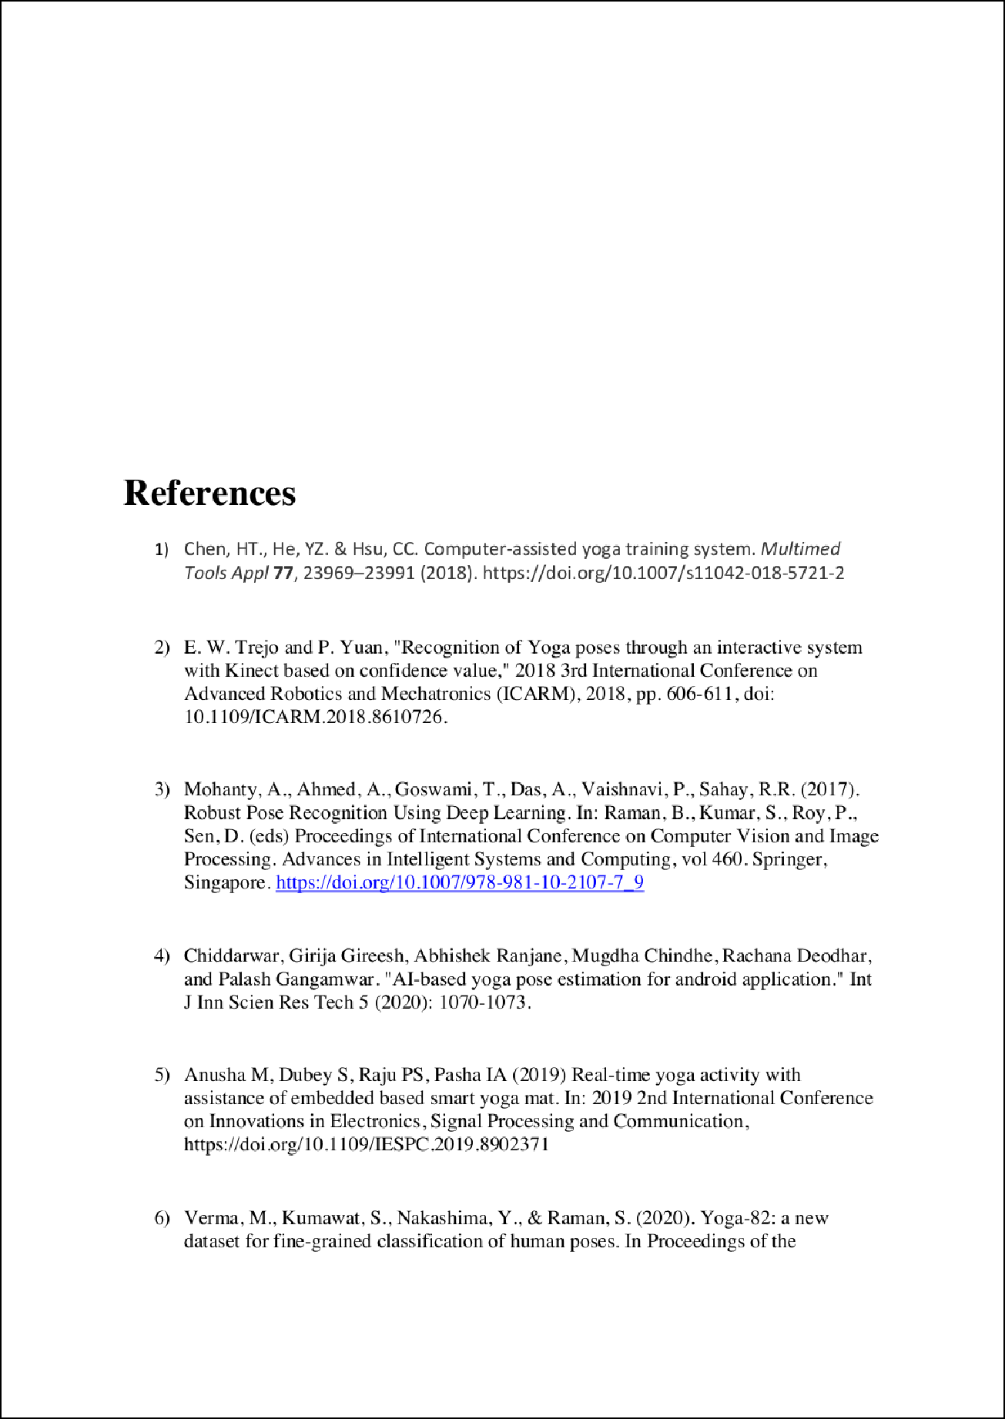



Final Report Submitted

9

ORIGINALITY REPORT

%

SIMILARITY INDEX

6%

INTERNET SOURCES

5%

PUBLICATIONS

2%

STUDENT PAPERS

PRIMARY SOURCES

link.springer.com

1

Internet Source

[www.coursehero.com](http://www.coursehero.com/)

2

Internet Source

[www.slideshare.net](http://www.slideshare.net/)

3

Internet Source

ijarsct.co.in

4

Internet Source

5 Youngpil Cha. "Satisfaction assessment of multi-objective schedules using neural fuzzy methodology", International Journal of Production Research, 1/20/2003

Publication

ntnuopen.ntnu.no

6

Internet Source

Submitted to University of Huddersﬁeld

7

Student Paper

uwspace.uwaterloo.ca

8

Internet Source

2%

2%

1%

<1%

<1%

<1%

<1%

<1%

9

10

11

12

13

14

15

"Advanced Computing Technologies and Applications", Springer Science and Business Media LLC, 2020

Publication

Submitted to Open University Malaysia

Student Paper

"Proceedings of Fifth International Congress on Information and Communication Technology", Springer Science and Business Media LLC, 2021

Publication

Carla Delmarre, Marie-Anne Resmond, Frédéric Kuznik, Christian Obrecht, Bao Chen, Kévyn Johannes. "Artiﬁcial Neural Network Simulation of Energetic Performance for Sorption Thermal Energy Storage Reactors", Energies, 2021

Publication

Submitted to Colorado State University, Global Campus

Student Paper

hubpages.com

Internet Source

personalhealthcare.info

Internet Source

<1%

<1%

<1%

<1%

<1%

<1%

<1%

16

17

18

19

20

21

Shakti Kinger, Abhishek Desai, Sarvarth Patil, Hrishikesh Sinalkar, Nachiket Deore. "Deep Learning Based Yoga Pose Classiﬁcation", 2022 International Conference on Machine Learning, Big Data, Cloud and Parallel Computing (COM-IT-CON), 2022

Publication

Submitted to University of Southern Queensland

Student Paper

Wu Liu, Qian Bao, Yu Sun, Tao Mei. "Recent Advances of Monocular 2D and 3D Human Pose Estimation: A Deep Learning Perspective", ACM Computing Surveys, 2022

Publication

[www.ijirset.com](http://www.ijirset.com/)

Internet Source

"Digital Techniques for Heritage Presentation and Preservation", Springer Science and Business Media LLC, 2021

Publication

Chhaihuoy Long, Eunhye Jo, Yunyoung Nam. "Development of a yoga posture coaching system using an interactive display based on transfer learning", The Journal of Supercomputing, 2021

Publication

<1%

<1%

<1%

<1%

<1%

<1%

22

23

P. M. Trivailo. "The inverse determination of aerodynamic loading from structural response data using neural networks", Inverse Problems in Science and Engineering, 6/1/2006

Publication

Santosh Kumar Yadav, Amitojdeep Singh, Abhishek Gupta, Jagdish Lal Raheja. "Real- time Yoga recognition using deep learning", Neural Computing and Applications, 2019

Publication

<1%

<1%

Exclude quotes On Exclude bibliography On

Exclude matches < 5 words